Krichhoff was a scientist who first explained the laws of current and voltage in a circuit. Krichhoff's laws are very important laws of electronic, although they are very simple. There are two laws name Krichhoff's Voltage Law (KVL) and Krichhoff's Current Law (KCL). They are explained below:

***Krichhoff's Voltage Law (KVL)***

KVL describes the relation between the voltages across different components in a circuit. It is defined as below:

**“In any mesh or loop of a circuit, the sum of all the voltages across components in the mesh is equal to zero.”**

Figure below shows this law in an example. In this example there can be a maximum of three meshes. In such cases as you can see in the example, everyone of the equations can be extracted from the other two. Therefore using only two of them is enough and and selecting which two is optional.

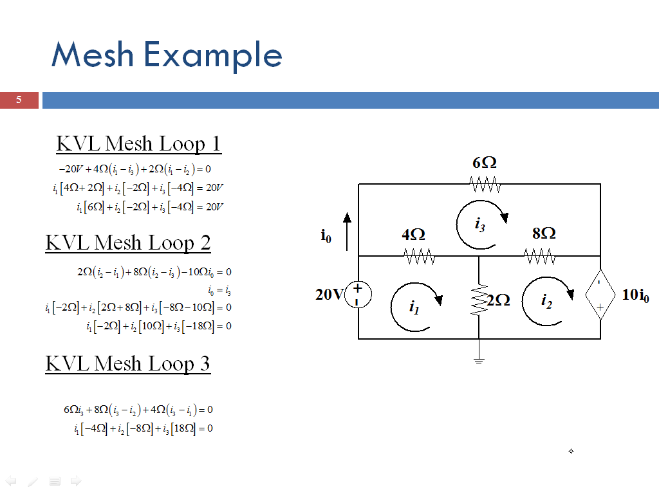

Selecting voltage polarity or current direction for a component of a circuit is optional, but as soon as you chose directions, you have to stick with them to avoid mistakes in calculations. Remember that when you are moving in a mesh to write the voltages, you always have to choose one direction to turn in the mesh loop from the beginning point to the end. Also selecting the mesh direction is optional and doesn't have any effect on the final result. If you enter from a terminal with a negative voltage to a component, you write a negative voltage for that component and if you enter a component from its positive side, you write a positive voltage for that component.

Now this is a very important rule:

**“The voltages across all the electrical components that are parallel to each other are equal.”**

***Krichhoff's Current Law (KCL)***

**“In any node of a circuit, the sum of all the incoming currents to the node is equal to the sum of all the outgoing currents.”**

Or assuming that all the current directions are to the node, the sum of all the currents is equal to zero, meaning that some of them are positive and some are negative. This law shows that it is not possible for the electrical charge to get accumulated in a node. What goes in a node, must come out. Figure below shows this law in an example:

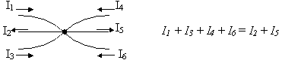

It is like several hoses connected to each other in a point and the volume of the water going into that point must be equal to the volume of the water coming out, because water cannot be stored in a divider point with a fixed size, more than its own volume.

Here is another important rule:

**“The currents in all the components in a branch, which are in series are equal.”**

KCL explains why the value of current in a branch in a circuit is always the same. Every node between two components connects to two links in a branch. If current goes in the node from one link, it doesn’t have anywhere else to go unless through the other link. Therefore the same current flows in the next component.

Using KVL and KCL laws, all the unknown current and voltage parameters in a circuit can be calculated. They usually give equations more than needed, which can be extracted from other equations. Choosing which equations to pick for calculations directly effects the difficulty of the problem and can make a simple problem quite confusing. It is something that requires practice and experience. Later on after knowing a couple of circuit components we can get to solving a couple of examples.